Lesson 2 Homework  FRONT PAGE | 3-12, 16, 17, 22, 23 (FRONT)  3-8, 11-15 odd, 16 (BACK)

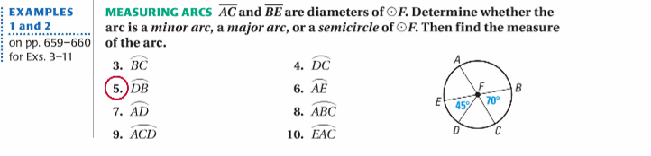

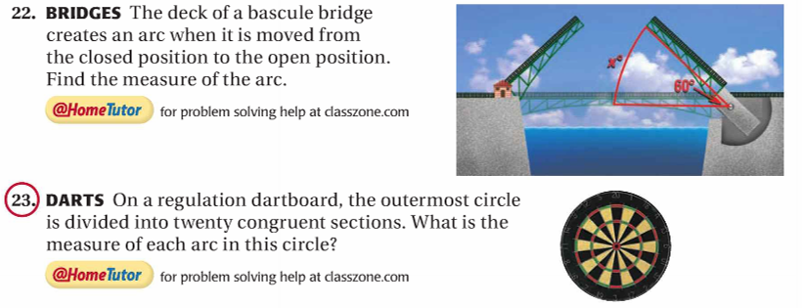

Lesson 2 Homework  BACK PAGE | 3-12, 16, 17, 22, 23 (FRONT)  3-8, 11-15 odd, 16 (BACK)
